Rayon
Rayon is a manufactured regenerated cellulose fiber. Because it is produced from naturally occurring polymers, it is neither a truly synthetic fiber nor a natural fiber; it is a semi-synthetic^{[1]} or artificial^{[2]} fiber. Rayon is known by the names viscose rayon and art silk in the textile industry. It usually has a high luster quality giving it a bright sheen.
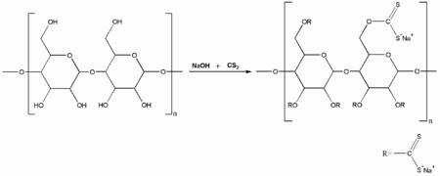

Cellulose is treated with alkali and carbon disulfide to yield viscose.

Cellulose acetate
Cellulose acetate (also known as zyl or zylonite),^{[1]} first prepared in 1865, is the acetate ester of cellulose. Cellulose acetate is used as a film base in photography, as a component in some adhesives, and as a frame material for eyeglasses;^{[1]} it is also used as a synthetic fiber and in the manufacture of cigarette filters and playing cards.
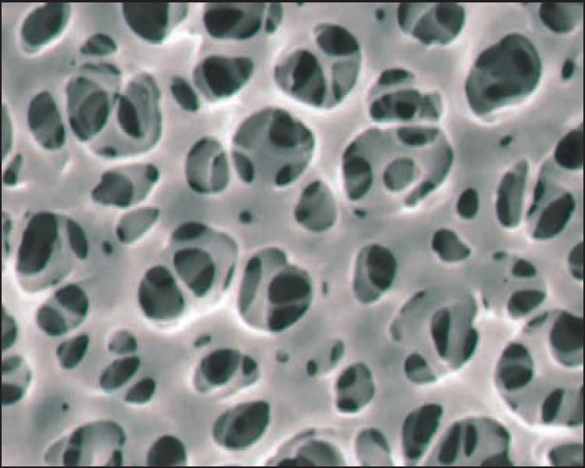

Nylon
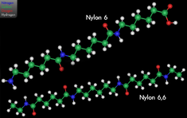Nylon 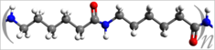
Density | 1.15 g/cm³
Electrical conductivity (σ) | 10⁻¹² S/m
Thermal conductivity | 0.25 W/(m·K)
Melting point | 463–624 K  190–350 °C  374–663 °F
Nylon is a generic designation for a family of synthetic polymers known generically as polyamides, first produced on February 28, 1935, by Wallace Carothers at DuPont's research facility at the DuPont Experimental Station. Nylon is one of the most commonly used polymers.

Modacrylic
A modacrylic is a synthetic copolymer. Modacrylics are soft, strong, resilient, and dimensionally stable. They can be easily dyed, show good press and shape retention, and are quick to dry. They have outstanding resistance to chemicals and solvents, are not attacked by moths or mildew, and are nonallergenic. Among their uses are in apparel linings, furlike outerwear, paint-roller covers, scatter rugs, carpets, and work clothing and as hair in wigs.^{[1]}
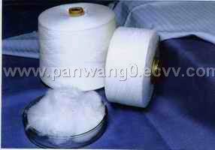

Olefin fiber
Olefin fiber is a synthetic fiber made from alkenes. It is used in the manufacture of various textiles as well as clothing, upholstery, wallpaper, ropes, and vehicle interiors. Olefin is also referred to as polypropylene, polyethylene, or polyolefin. Olefin's advantages are its strength, colourfastness and comfort, stain, mildew, abrasion and sunlight resistance, and good bulk and cover. ^{[1]}
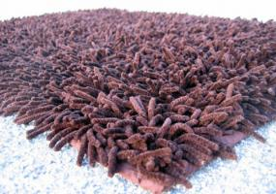

Acrylic fiber
Acrylic fibers are synthetic fibers made from a polymer (polyacrylonitrile) with an average molecular weight of ~100,000, about 1900 monomer units. To be called acrylic in the U.S, the polymer must contain at least 85% acrylonitrile monomer. Typical comonomers are vinyl acetate or methyl acrylate. The Dupont Corporation created the first acrylic fibers in 1941 and trademarked them under the name "Orlon".^{[1]}
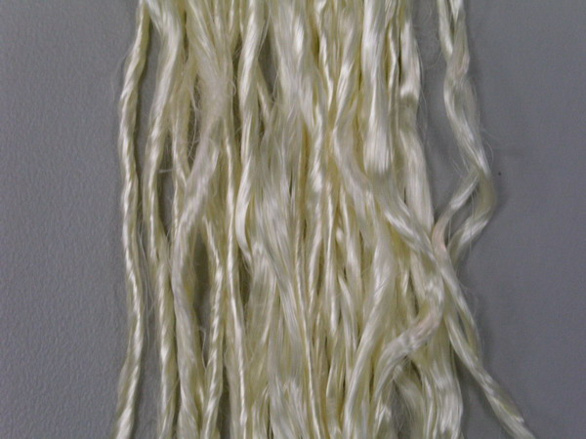

Polyester
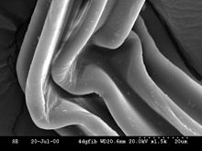

SEM picture of a bend in a high-surface area polyester fiber with a seven-lobed cross section
Supermacro closeup of a speaker cover fabric
Polyester is a category of polymers which contain the ester functional group in their main chain. Although there are many polyesters, the term "polyester" as a specific material most commonly refers to polyethylene terephthalate (PET). Polyesters include naturally-occurring chemicals, such as in the cutin of plant cuticles, as well as synthetics through step-growth polymerization such as polycarbonate and polybutyrate. Natural polyesters and a few synthetic ones are biodegradable, but most synthetic polyesters are not.

Carbon (fiber)
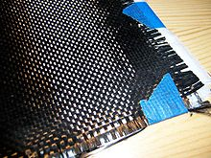
Fabric made of woven carbon filaments
Carbon fiber (carbon fibre), alternatively graphite fiber, carbon graphite or CF, is a material consisting of extremely thin fibers about 0.005–0.010 mm in diameter and composed mostly of carbon atoms. The carbon atoms are bonded together in microscopic crystals that are more or less aligned parallel to the long axis of the fiber. The crystal alignment makes the fiber very strong for its size. Several thousand carbon fibers are twisted together to form a yarn, which may be used by itself or woven into a fabric.

Spandex
From Wikipedia, the free encyclopedia
Jump to: navigation, search
Spandex or elastane is a synthetic fibre known for its exceptional elasticity. It is strong, but less durable than natural Latex, its major non-synthetic competitor. It is a polyurethane-polyurea copolymer that was co-invented in 1959 by chemists C. L. Sandquist and Joseph Shivers at DuPont's Benger Laboratory in Waynesboro, Virginia. When first introduced, it revolutionized many areas of the clothing industry.
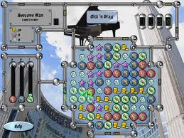
The name "spandex" is an anagram of the word "expands".^{[1]} It is the preferred name in North America; in many European countries it is referred to as "elastane", and is known in Britain mainly as LYCRA. Brand names for spandex include LYCRA (made by INVISTA, previously a part of DuPont), ELASPAN (also INVISTA's), Creora (Hyosung), ROICA and Dorlastan (Asahi Kasei), Linel (Fillattice), and ESPA (Toyobo).

Aramid
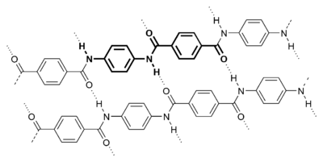

Aramid fibers are a class of heat-resistant and strong synthetic fibers. They are used in aerospace and military applications, for ballistic rated body armor fabric and ballistic composites, in bicycle tires, and as an asbestos substitute. The name is a portmanteau of "aromatic polyamide". They are fibers in which the chain molecules are highly oriented along the fiber axis, so the strength of the chemical bond can be exploited.

Modal (textile)
From Wikipedia, the free encyclopedia
Jump to: navigation, search
 | This article needs additional citations for verification. Please help improve this article by adding reliable references. Unsourced material may be challenged and removed. (February 2010)
Modal is a cellulose fiber made by spinning reconstituted cellulose from beech trees. It is about 50% more hygroscopic (water-absorbent) per unit volume than cotton. It takes dye like cotton, and is color-fast when washed in warm water. Modal is essentially a variety of rayon.^{[1]}
Textiles made from Modal are resistant to shrinkage and fading, but prone to stretching and pilling. They are smooth and soft, more so than mercerized cotton, to the point where mineral deposits from hard water do not stick to the fabric surface. Modal fabrics should be washed at lower temperatures, and ironed after washing
. 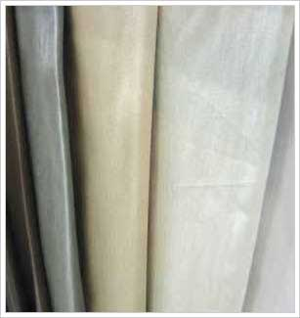

Vinylon
From Wikipedia, the free encyclopedia
(Redirected from Vinalon)
Jump to: navigation, search
Vinylon
Chosŏn'gŭl | 비날론
McCune–Reischauer | Pinallon
Revised Romanization | Binallon
Vinylon (also Vinalon) is a synthetic fiber, produced from polyvinyl alcohol, using anthracite and limestone as raw materials. Vinalon was first developed in 1939 by Japanese scientist, Ichiro Sakurada, Yi Sung-ki [Lee. S.or Ri.Sung.Gi.] and H. Kawakami^{[1]} Production of this fiber was delayed for WW2. The fibre was largely ignored in Korea until Ri defected to North Korea in 1950. Trial production began in 1954 and in 1961 the massive February 8 Vinalon Complex was built in Hamhung.^{[2]} Its success and widespread usage in North Korea is often pointed to in propaganda as an example of the success of the juche philosophy.^{[3]}
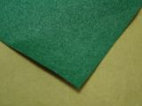

Saran (plastic)
From Wikipedia, the free encyclopedia
Jump to: navigation, search
It has been suggested that this article or section be merged with Polyvinylidene_chloride. (Discuss) Proposed since March 2009.
Saran is the trade name for a number of polymers made from vinylidene chloride (especially polyvinylidene chloride or PVDC), along with other monomers. The main advantage of Saran film is its very low permeability to water vapor, flavor and aroma molecules, and oxygen compared with other plastics. The barrier to oxygen prevents food spoilage, and the barrier to flavor and aroma molecules helps food retain its flavor and aroma.
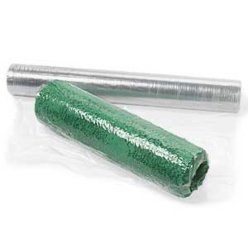

Vinyon
From Wikipedia, the free encyclopedia
Jump to: navigation, search
This article does not cite any references or sources. Please help improve this article by adding citations to reliable sources. Unsourced material may be challenged and removed. (December 2009)
Vinyon is a synthetic fiber made from polyvinyl chloride. In some countries other than the United States, vinyon fibers are referred to as polyvinyl chloride fibers. It can bind non-woven fibers and fabrics. It was invented in 1939.
It has the same health problems associated with chlorinated polymers. In the past, Vinyon was used a substitute for plant-based filters in tea bags.
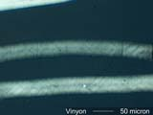

Ultra-high-molecular-weight polyethylene
From Wikipedia, the free encyclopedia
(Redirected from Dyneema)
Jump to: navigation, search
 | This article has multiple issues. Please help improve it or discuss these issues on the talk page.  - It needs additional references or sources for verification. Tagged since February 2010.  - It may require general cleanup to meet Wikipedia's quality standards. Tagged since February 2010.
Ultra-high-molecular-weight polyethylene (UHMWPE or sometimes shortened to UHMW), also known as high-modulus polyethylene (HMPE) or high-performance polyethylene (HPPE), is a subset of the thermoplastic polyethylene. It has extremely long chains, with molecular weight numbering in the millions, usually between 2 and 6 million. The longer chain serves to transfer load more effectively to the polymer backbone by strengthening intermolecular interactions. This results in a very tough material, with the highest impact strength of any thermoplastic presently made.^{[citation needed]} It is highly resistant to corrosive chemicals, with exception of oxidizing acids. It has extremely low moisture absorption, has a very low coefficient of friction, is self-lubricating, and is highly resistant to abrasion (in some forms, 15 times more resistant to abrasion than carbon steel). Its coefficient of friction is significantly lower than that of nylon and acetal, and is comparable to that of polytetrafluoroethylene, but UHMWPE has better abrasion resistance than PTFE. It is odorless, tasteless, and nontoxic.
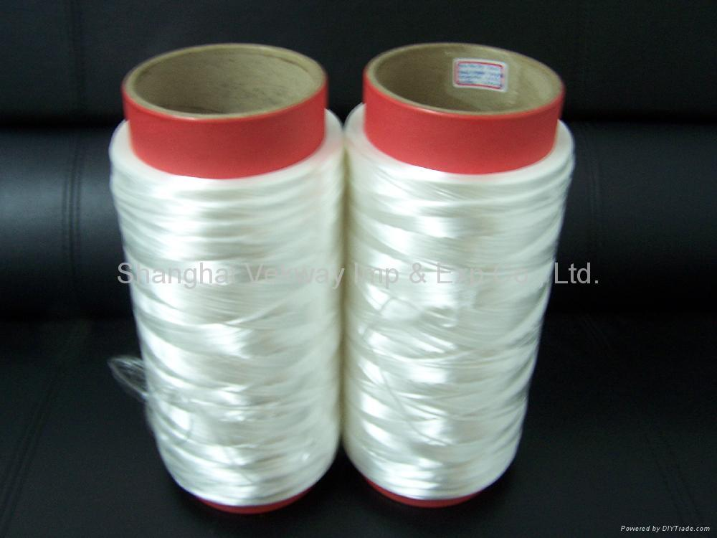

Polybenzimidazole fiber
From Wikipedia, the free encyclopedia
Jump to: navigation, search
Polybenzimidazole (PBI) fiber (1983) is a synthetic fiber with an extremely high melting point that also does not readily ignite, because of its exceptional thermal and chemical stability. The Federal Trade Commission definition for PBI fiber is "A manufactured fiber in which the fiber-forming substance is a long chain aromatic polymer having recurring imidazole groups as an integral part of the polymer chain". Kermel, a polyamidoimide, is a related "high performance polymer."

Poly(p-phenylene sulfide)
From Wikipedia, the free encyclopedia
Jump to: navigation, search
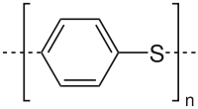
Polyphenylene sulfide
Polyphenylene sulfide (PPS) is an organic polymer consisting of aromatic rings linked with sulfides. Synthetic fiber and textiles derived from this polymer are known to resist chemical and thermal attack. PPS is used to make filter fabric for coal boilers, papermaking felts, electrical insulation, specialty membranes, gaskets, and packings. PPS is the precursor to a conducting polymer of the semi-flexible rod polymer family. The PPS, which is otherwise insulating, can be converted to the semiconducting form by oxidation or use of dopants.^{[1]}

Lyocell
From Wikipedia, the free encyclopedia
Jump to: navigation, search
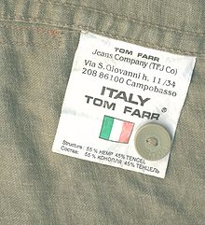
The label of a coat with Tencel
Lyocell is a regenerated cellulose fiber made from dissolving pulp (bleached wood pulp). It was first manufactured in 1987 by Courtaulds Fibres UK at their pilot plant S25. As of 2010 it is manufactured by Lenzing AG of Lenzing, Austria, under the brand name "Lyocell by Lenzing", and under the brand name Tencel by the Tencel group, now owned by Lenzing AG.^{[1]}

Polylactic acid
From Wikipedia, the free encyclopedia
(Redirected from Polylactide)
Jump to: navigation, search
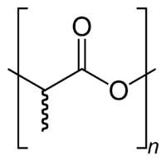
The skeletal formula of poly(lactic acid)
Poly(lactic acid) or polylactide (PLA) is a thermoplastic aliphatic polyester derived from renewable resources, such as corn starch (in the United States), tapioca products (roots, chips or starch mostly in Asia) or sugarcanes (in the rest of world). It can biodegrade under certain conditions, such as the presence of oxygen, and is difficult to recycle.

M5 fiber
From Wikipedia, the free encyclopedia
Jump to: navigation, search
M5 fiber (polyhydroquinone-diimidazopyridine) is a high-strength synthetic fiber first developed by Dr. Doetze Sikkema^{[1]} and his team at the Dutch chemical firm Akzo Nobel. Currently, it is being produced by the United States Magellan chemical company.
